Packaging Winget App with PowerShell Wrappers for Intune Deployment
This guide outlines a step-by-step process for packaging and deploying applications using Winget and Microsoft Intune, including identifying the app ID, obtaining logos, updating installation scripts, packaging with IntuneWinAppUtil, uploading to Intune, configuring app settings, and assigning the app to user or device groups.

Contents
Identify the App ID from Winget 2
Obtain the Logo 2
Update Winget App Name in the Following Files 2
install.vbs 2
uninstall.vbs 2
detection.ps1 3
Package the App with IntuneWinAppUtil 3
Upload to Intune 3
Configure the Intune App Settings 3
Assign the App 4
Testing & Validation 4
Summary 4

Identify the App ID from Winget
Open PowerShell 7 and run the following command to search for the desired application:
winget search "<AppName>"
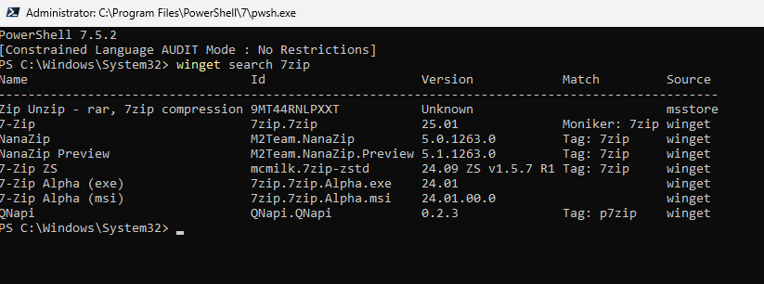
Locate the correct application in the list and note its Id (e.g. Microsoft.Edge or 7zip.7zip).

Obtain the Logo
Search for a high-resolution official logo of the application (preferably a .png or .jpg file).
Save the logo in the root of the template folder, ideally naming it icon.png or icon.jpg.

Update Winget App Name in the Following Files
Update the Winget app ID (identified in step 1) in all three of the following files:

install.vbs
This script launches the PowerShell 7 installer using wscript.exe.
Edit the install.ps1 reference or embedded content to include the correct Winget app ID.
This script is used in Intune as the install command:
wscript.exe ".\install.vbs"

uninstall.vbs
Like the install script, this file triggers a Winget uninstall command via a PowerShell 7 script.
Update the referenced Winget ID to match the app's uninstall identifier.
Used in Intune as the uninstall command:
wscript.exe ".\uninstall.vbs"

detection.ps1
This PowerShell 7 script is used to detect whether the app is already installed.
It also will check if there are any newer versions of the app if you did not specify a particular version, eg; Version = Latest will always look to see if there is a newer version, whereas Version = 7.2.0 will not as this is design to prevent updates to the app to allow it to remain on same version until increased in the detection.ps1 file.
This process was created by Damien.Cresswell@sistena.co.uk and is not used anywhere else (date 28/08/2025).

Package the App with IntuneWinAppUtil
Use the Microsoft Win32 Content Prep Tool (IntuneWinAppUtil.exe) to package the folder:
- Source folder: The folder containing your scripts and icon
- Setup file: Select install.vbs
- Output folder: Choose a location for the .intunewin output (e.g. .\output)
Example CLI usage:
IntuneWinAppUtil.exe -c "C:\YourFolder" -s "install.vbs" -o "C:\YourFolder\output"

Upload to Intune
Sign into the Microsoft Intune admin center.
Navigate to Apps > Windows > Add > App type: Windows app (Win32).
Upload the .intunewin package from the output folder.

Configure the Intune App Settings
- Add the icon: Upload the icon.png or .jpg you saved earlier.
- App name & description: Provide a clear, user-friendly name and description of the application.
- Publisher: Use the name from the Winget package or the official vendor.
- Command-line arguments: Ensure these are correctly populated as:
Install command: wscript.exe ".\install.vbs"
Uninstall command: wscript.exe ".\uninstall.vbs"
- Detection rules:
- Choose "Use a custom detection script".
- Upload the Detection.ps1 file.
- Ensure it is set to run as system and 64-bit.

Assign the App
Under Assignments, add the user or device groups that should receive the application.
Configure availability (Required / Available for enrolled devices) as needed.

Testing & Validation
After deployment, check logs at:
C:\ProgramData\dbcargouk.com\<ComputerName>\<AppName>_install.txt
Logs are automatically uploaded to Blob Storage (as configured) using AzCopy.

Summary
Component | Description
Install-Launcher.ps1 | Intune's entry script; runs in 64-bit context
Install-Wrapper.ps1 | Actual install logic, logging, and AzCopy upload
YourInstaller.exe | The .exe being deployed
.intunewin file  Uninstall-Launcher.ps1  Uninstall-Wrapper.ps1 | Final packaged app for upload to Intune  Intune's entry script; runs in 64-bit context  Actual install logic, logging, and AzCopy upload

